# Report

## 12-05-2019_Glenn-André-Patrick-Key_SP_FP

### Community Science Museum

It’s been 9 joyful, exciting, challenging, head-scratching weeks. Starting off with planning phase until the initial test/launch phase and a whole lot of “uhh…”

The project has had its ups and downs, (mostly ups) and I’ve come to realize how much I have learnt compared to myself 1 year ago. Using techniques, I couldn’t even start to think about when I first applied for this Front-End course; Following through tasks that I made for myself for my own project and, making it look like I imagined.

The key moments during these 9 eventful weeks has been creating the Gantt chart; This was our most recent course and, it really came in handy making this project “easier” than the previous projects. I used Illustrator and Photoshop, pen and paper. Creating rough sketches from the pen, too a mood/style tile on illustrator. Photoshop came in handy creating image filters, resizing and editing images to fit my sketching.

Biggest challenge was having to leave for National Guard training for a week and, using the holidays with family to prioritize the project; thankfully everyone has been very supportive (and even been apart of the evolution of the project).

In this report I will start by writing about what the task was, and my interpretation of the assignment. Then I’ll move on to what tools and guidance I’ve had to be inspired into creating my own twist and understanding of the assignment. For the next part I will dig into Color choices, typography, styling, working process, layout and grid. Finally, sources and self-taken images of my pencil sketching. PDF files including the style tile and Gantt chart will be delivered ass an add-on file next to this Word document.

### Tasks for Science Museum Project

For this Gantt sheet, I have decided to include a «crucial» timeline with the main tasks going down the waterfall. These will be displayed above the orange thick line, separating them from the smaller tasks.

Beneath the orange line, the tasks that must be completed will be displayed within their «main task group» between the Horizontal Color lines. This will help keep track of smaller tasks that has to be completed in order to «check» the main task above the orange line. The minor tasks are also grouped in such way that they «match» their main timeline by using a vertical arrow line. For the next build phase too start, all the tasks must be completed. This will also give a good indication on where I am according to schedule. The Green glowing bar shows «today». The red bars are eventually filled with green as the task move along – indicating its completion.

### The Code

We were asked to create a Science Museum Page that would appeal to both parents and «smart children». For the project we were handed out the content and, told to create about 4-6 pages ++. Other criteria were starting off with a plan on how we would approach it, and how long it would take us.

I decided to approach the task with a simple ‘’Gantt Chart’’ that we recently learned about in the previous assignment. Here I could plan out and estimate the time I would think it takes; I also made the chart flexible in terms of adding the ‘’Actual’’ time used to complete the task.

The main issue in my case – was to figure out the design of the page. How do you create a page with only yourself to work with and no real input from outside? How does the page become something a client wants – without giving it too much of yourself?

In order to successfully accomplish my goal (I hope) I had to do some research around the web; Mainly other science museum pages; as this is the target site in the end – I would also ask a couple of other friends and developers on what *they* thought & put together something more general to create a simple, easy to use and informative science museum page.

### Inspiration

My go to inspiration source since the beginning of this study has been, YouTube. There are plenty of video tutorials, designs, tips and tricks that are for everyone to be inspired. Bootstrap also has plenty of ideas and «finished» themes, that do cost to use but displayed.

My brother in law works as a developer, taking a study and writing a master’s degree in data science. He was working on a project himself; I found it very useful to see what he would use when he would create pages. We also spent a week together along with ‘svigers’ (father in-law) on our Easter break at Senja; giving me plenty of time to ask questions and discuss designs we see every day on the web*.*

### WORK PROCESS

Following the Gantt Chart – I started off by searching the web and sketching an idea on paper, bills, notebook. This was just to get a rough idea on what I was seeing in my head. Then I proceeded to Adobe Illustrator and made a style tile to sketch out the ideas for, texture, typography, heading, picture styles, colors and swatches. I also researched on the phenomenon ‘Bootstrap’ as plenty of my friends whom work as developers recommended that I try it out.

After everything was planned, it was just to start the writing and it has been even more flowing than before, after I had finished the HTML ‘skeleton’ it was just to start styling and seeing the page become more like I had imagined– as the project moved on new ideas and thoughts would appear (which I guess is normal in a project your working on by yourself).

#### STYLE

In terms of how the page compares to modern internet culture, I went with a more “flow” page that would see background images in a fixed manner as the page scrolls by. Keeping it simple and using the white space to my favor. I wanted my swatches to come out as a filter layer on the images to give it some stylish color without breaking the natural modern flow of the page. I have seen plenty of 90’s early 2000’s pages with colorful themes that would look old, and somewhat weird when exploring the web today, especially kids’ pages.

#### TYPOGRAPHY

When choosing font styles, I tried googling good combinations for web pages, also check the google fonts for their recommended combinations. There are plenty of good combinations recommended on the web today, so this was no issue. Google fonts even have a preview showing how it will look like together. After some back and forth trying out different combinations I found *‘Montserrat’* and *‘Merriweather’* to go good together – also because going for “similar” fonts can be a safe approach as it doesn’t completely opposite each other which I’ve gotten the impression of can be a mess; Don’t get me wrong, sometimes or most likely contrast can be a good thing.

I chose the Merriweather, Montserrat combo since it looks modern and clean. It makes it easy to read and goes good with the ‘theme’. I also thought about potential children also exploring the page, and since one of the target audience is smart children, they tend to like more “adult” reading.

Making the decision I’ve use sources like: Design for Hackers Reverse Engineering Beauty - David Kadavy pg. 301, 307-310.

Google popular font pairing: <https://fonts.google.com/specimen/Merriweather>

Montserrat pairing: <https://webdesignersjourney.wordpress.com/tag/montserrat-font-combination/>

#### COLORS

When picking out color swatches, I’ve used ‘coolors.co’. This page lets you pick colors that are generated (claimed by colors) to fit. I wanted easy on the eye and web supported colors with good contrasts; and, colors that keep the page modern without going all over and crazy with decorative splash. I wanted the page to have a professional look but at the same time give the background images color filters to attract the eye. To give the page a trustworthy status and a “home-feeling-science museum” web page - I felt it had to use dark filters on the images and dark header/navigation to contrast the light background and showcase the colors of the images. Nothing really is the answer when playing around with contrast & color, but personally I hope clever children would find it interesting without being chased or scared away (hence the early ‘’For Kids” header). it’s the parents that need convincing and I feel the easy grey-white-light-dark layout makes it trustworthy and easy on the eyes.

#### COMPOSITION, LAYOUT, GRID AND OTHER ELEMENTS

I wanted to create a big header screen to give the page a natural modern look, and then make the page a three-column style page with color filter images to create spacing between the columns. This three-column page will convert into a 2 plus 1 column in medium sized screen and 1 column on mobile. The reason for the 2 plus 1 style really is to make the page more dynamic, and to prevent huge spaces on the right giving it an awkward look. In the future I would test this style as well since it might work, but I’ve gotten the impression humans tend to like order and equality; things that align center.

The pages also have a systematic layout. I wanted to put the provided content that was similar on the same page. For the home page (Community Science Museum) I decided to give a brief intro about the highlights of the page – as well as showcasing the different “sections” that might attract interest of maybe a teacher or a researcher. I also decided to give the images after the ‘kids’ section a rounded border style to be more “eye-catching”; alongside putting a “learn more” button to navigate to the pages that contain more info about the subject. Most of the navigation buttons on the page is on the ‘main’ page, as I deliberately don’t want users to end up in an ongoing loop.

The layout is used with a ‘*CSS Bootstrap’* fluid grid for the most part, alongside some personal *CSS* styling. Navigation is also fluid, and only visible above the header – this to prevent a huge piece of block following (especially on mobile/smaller device) – I did consider having it showing when you scroll upwards - but in my opinion, it would make the design bulky and unpredictable. The navigation is set to be displayed as text on larger screens. On smaller screens, it would be displayed as a *‘Bootstrap’* icon; That would turn into a dropdown menu once pushed, this would apply for the smaller screens.

I also decided to put background images to some of the *div* elements, mainly on the larger screens that would be removed on the smaller screens – this was an idea that came up to me when I started building and from the feedback I got, it looked like it worked well.

Since android and iOS doesn’t support “fixed” background images (fixed in terms of not moving along with the content, but stationary set on the background of the body) I went with static images that I edited up in ‘*Photoshop’*. This issue turned out to be the most time-consuming task I had to deal with in this project. I asked friends of mine who are developers, but it was difficult to figure out a solution (hence why I went with static in terms of images moving along with the content). I have taken notes and will see if I can find a fix but, from what I have read on the internet; it doesn’t seem android nor iOS supports this effect yet.

### What Have I Learned?

At first when I read our assignment, I was not too sure on how to start but, it didn’t take long before everything fell into place. The lessons and assignments we’ve had throughout this semester has given us the tools to create a project like this. It really is amazing on how quickly I learn and comparing it to when we started off in august 2018, I’ve surely come along way. I have also experienced that the world of developing just keep getting more complex but, I’ve taken one step further.

Strategically I would use the same planning method as we’ve/I have done during this project. Working with Gantt chart and really get an overview really had its benefits. The skills of illustrator and photoshop really was in good use and, using the internet to find solutions to issues that would appear. I found working strategy with good planning and preparation made the whole project itself easier to follow through.

Experimenting with ‘*Bootstrap*’ was completely different from what I had in mind; I have never touched Bootstrap (it has not been relevant). It was a fun learning curve and gave me a better understanding of styling, and CSS in general; as you need to use the same targeting of classes and ID’s. Starting over again or a on a different project, I would dig deeper into *SCASS*. SCASS is from what I understand; a more lucidly way of writing *CSS.* SCASS briefly is a way of writing *CSS* snippets and creating the snippets as 1 common style, that you can *‘@import’* to other id’s or classes. It makes it easier to create different types of styling that can be used over again without copying the whole selector if you want to use it again.

### SOURCES AND REFERENCES

Design for Hackers Reverse Engineering Beauty - David Kadavy pg. 301, 307-310.

Google popular font pairing: <https://fonts.google.com/specimen/Merriweather>

Montserrat pairing: <https://webdesignersjourney.wordpress.com/tag/montserrat-font-combination/>

Color Pallette: <https://coolors.co/>

## Main Tasks

* Research
* Design
* HTML/CSS
* Testing
* Report

## Minor Tasks

#### Research:

* Create Gantt
* Analyze Assignment
* Write Schedule Report
* Planning Document
* Create Git Repo
* Arrange Folders
* Draw pencil sketches (4-6 pages)

#### Design

* Create Mood board/Style Tile (Color scheme, Typo,)
* Arrange pictures and content (Logo, Picture resizing etc.)
* Write status report, add it on the planning document
* Find CSS Inspiration and cleaver snippets

#### HTML/CSS

* Create HTML Markup (4-6 pages)
* Create CSS for Mobile Device
* Create CSS for Laptop
* Create CSS for Desktop
* 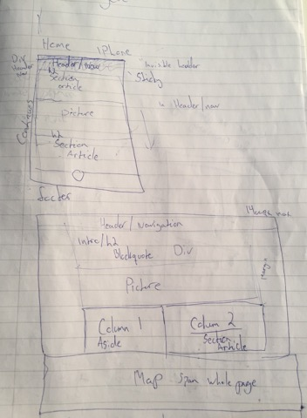Upload Page to site ([www.glennkey.no](http://www.glennkey.no))
* Test page through friends, family WCAG.
* Write Progression report, add too planning document

#### Submission

* Write Report, finish it
* Submit page to Moodle

# Notes:

* Need to fix the images to fit the «front page»/Size Correction
* Need to fix the images to be more appealing for the header.
* Add Header images to fill all navigation choices.
* 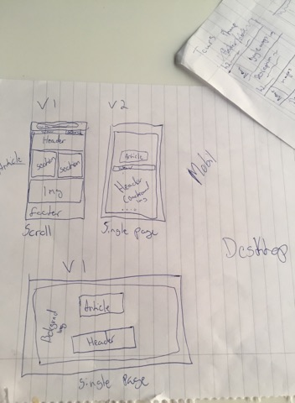In the explore page in the 3 column article, there should be a cover image after each article in mobile size (one column) 1 single cover image in the medium desktop (two column) and in the three column, keep the cover image but add the svg files/icons to the paragraphs
* Add the «get involved to explore.html» it should be its own section underneath the main, as a <*aside role=’’complementary’’*> element.
* Special Events, background elephant image needs a phone version
* Ant background in exhibition spaces needs to be made smaller and more mobile friendly
* Might consider making the sliders smaller in size
* 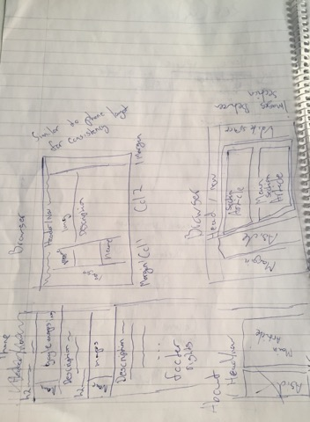Make a link_Blank to the img – in full size??
* Give the main html its full name for SEO.